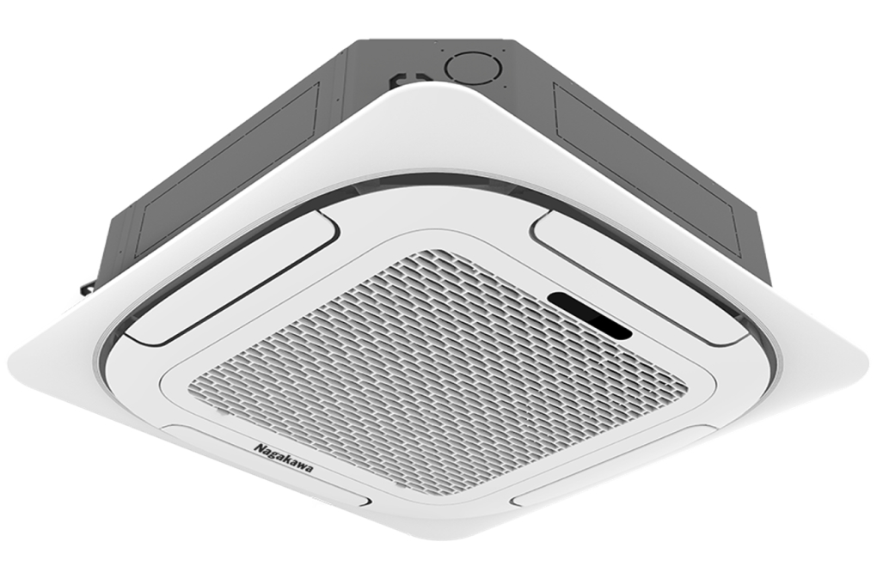

**21.000.000₫**

**Technical specifications of Nagakawa 2 HP ceiling air conditioner NT-C18R1T20**

* Machine Type:

1 way (cooling only) No Inverter

* Cooling capacity:

2 HP - 18,000 BTU

* Effective cooling range:

From 20 - 30m² (from 60 to 80m³)

* Dust filter, antibacterial, deodorant:

Dust filter mesh

* Power saving technology:

Eco

* Rapid cooling:

Super

* Utilities:

LED display screen

* Cooler:

Length 84 cm - Height 84 cm - Thickness 24.5 cm - Weight 22 kg

* Outdoor:

Length 54 cm - Height 76 cm - Thickness 26 cm - Weight 32 kg

Introducing the company 

- Vietnamese brand.  
- Established in 2002.  
- Diverse business products: air conditioners, dishwashers, induction cookers,.... with product prices easily accessible to consumers.  
- Achieved many outstanding achievements: Top 100 best products for families and children (2023), golden brand for Vietnamese health (2019),...

***This product has a recessed ceiling design that helps the project become modern and become a highlight when used. Not only cooling, this air conditioner also ensures many special benefits such as Eco power saving, Super fast cooling and air purification thanks to the filter.***

**Design overview**

**Cooler**

- Nagakawa 2 HP NT-C18R1T20 ceiling air conditioner is designed in a square shape with four curved corners as a highlight for the product. With a neutral white color and a [ceiling-mounted air conditioner](https://www.dienmayxanh.com/may-lanh-am-tran) , it is easy to combine with the design of the building.

- The air conditioner has a thin, compact design, only 24.5 cm thick and has a drainage pump with a pressure of up to 750 mm, so it is suitable for many types of projects such as buildings, factories, offices and even places with low ceilings.

**Outdoor**

The design is quite square and rectangular in shape with a sturdy steel shell. Copper gas pipes should ensure good heat conductivity combined with Hydrophilic-coated aluminum heatsinks that have optimal oxidation and water resistance, helping to increase the machine's durability when kept in outdoor spaces.

**Refrigeration technology**

[- Air conditioner](https://www.dienmayxanh.com/may-lanh?g=2-hp) capacity is 2 HP so the cooling ability is suitable for areas from 20 - 30m² (from 60 to 80m³).

- In Super mode, [Nagakawa air conditioner](https://www.dienmayxanh.com/may-lanh-nagakawa) operates with more powerful capacity, thereby quickly making the room cool, creating comfort and ease.

**Air blowing mechanism**

Operating with a 360-degree air swing mechanism, the blown air diffuses evenly throughout the room, helping to cool evenly.

**Power saving technology**

This ceiling air conditioner has an Eco mode to help save electricity more optimally. When activating the mode, the air conditioner automatically increases 2⁰C above the set temperature, thanks to which the compressor operates at optimal performance to help save maximum electricity when in use.

**Dust filtering ability**

In particular, there is a dust filter designed with multi-layer filters that can remove fine dust particles to help keep the space cleaner and fresher. At the same time, it also helps ensure that [the air conditioner](https://www.dienmayxanh.com/may-lanh) always operates smoothly during use.

**Utilities**

The LED display screen helps users conveniently monitor the mode being used.

*Overall,*[*the Nagakawa 2 HP NT-C18R1T20 ceiling air conditioner*](https://www.dienmayxanh.com/may-lanh/am-tran-nagakawa-2-hp-nt-c18r1t20)*will  basically meet your family's cooling needs with fast cooling, saving electricity, filtering dust, and creating a fresh space. The product is suitable for spaces such as restaurants, buildings, offices, factories, etc.*